East Area Planning Committee | 7th December 2016

Application Number: | 16/02002/RES
Decision Due by: | 14th November 2016
Proposal: | Erection of community sports pavilion with associated car and cycle parking and landscaping (Reserved Matters of outline planning permission 13/01383/OUT).
Site Address: | Land West Of Barton North Of A40 And South Of Bayswater Brook Northern By-Pass Road Wolvercote Oxford. Site plan at Appendix 1
Ward: | Barton And Sandhills Ward

Agent: | Mr Paul Comerford | Applicant: | Mr Mitchell

Recommendation:

East Area Planning Committee is recommended to resolve to grant the reserved matters.

Reasons for Approval

1 The re-provision of the community sports pavilion and associated access and parking facilities have been designed to accord with the Parameter Plans and Design Code approved as part of the original Outline Planning Application, as well as national, regional and local planning policy objectives to help create a high quality, inclusive development which promotes efficient use of land and incorporates a balanced range of land uses to form a complete neighbourhood. The proposed facilities will form part of the wider community hub that will support the whole of the Barton Park site and provide new facilities for the wider community. They will make a key contribution to the creation of a community focal point for the new and existing communities.

2 The Council considers that the proposal accords with the policies of the development plan as summarised below. It has taken into consideration all other material matters, including matters raised in response to consultation and publicity. Any material harm that the development would otherwise give rise to can be offset by the conditions imposed.

Conditions

1 Piling methods statement

2 verification report - contaminated land

3 Watching brief - contaminated land

Legal Agreement:

A legal agreement is not required to support this reserved matters as this was secured in association with the outline permission. Details of that legal agreement are contained in the Committee report for the outline application ref.: 13/01383/OUT. A CIL payment is not required as outline planning permission was granted before the introduction of CIL in Oxford.

Principal Planning Policies:

Oxford Local Plan 2001-2016

CP1 - Development Proposals
CP6 - Efficient Use of Land & Density
CP8 - Design Develpmt to Relate to its Context
CP9 - Creating Successful New Places
CP10 - Siting Develpmnt to Meet Functionl Needs
CP11 - Landscape Design
CP22 - Contaminated Land
TR3 - Car Parking Standards
TR4 - Pedestrian & Cycle Facilities
NE15 - Loss of Trees and Hedgerows
SR2 - Protection of Open Air Sports Facilities

Core Strategy

CS2_ - Previously developed and greenfield land
CS3_ - Regeneration areas
CS7_ - Land at Barton
CS9_ - Energy and natural resources
CS10_ - Waste and recycling
CS12_ - Biodiversity
CS13_ - Supporting access to new development
CS18_ - Urb design, town character, historic env
CS19_ - Community safety
CS20_ - Cultural and community development
CS21_ - Green spaces, leisure and sport

Barton AAP – Submission Document

MP1 - Model Policy
BA5_ - Sustainable travel
BA13_ - Design
BA14_ - Delivery
BA15_ - Flooding
BA16_ - Surface water drainage
BA17_ - Water supply and waste water drainage
BA18_ - Land remediation
BA11_ - Community hub

Other Planning Documents

National Planning Policy Framework
Planning Policy Guidance

Public Consultation by the Applicant

A Statement of Community Involvement has been submitted with this application (as part of the Planning Statement section 6) setting out the community engagement and stakeholder consultation process undertaken. Details can be seen at Appendix 2. Stakeholder engagement has included working closely with the Phoenix Sports Association

There has also been pre-submission consultation through regular meetings with officers of the City and County Councils, the sports club members and with the Oxford Design Review Panel (a workshop - response as set out in Appendix 3). The applicants response to the points raised by ODRP can be seen at Appendix 4. Officers are satisfied that the submitted proposals have emerged from a rigorous assessment-involvement-evaluation-design process rather than being a pre-determined design solution.

Public Consultation by the Local Authority

The Council’s normal consultation procedure has resulted in the following comments

Statutory and Non-Statutory Consultees and Groups:

- West Oxfordshire District Council: have no observations or comments to make on this occasion.

- Historic England: The application(s) should be determined in accordance with national and local policy guidance, and on the basis of your specialist conservation advice.

- Natural England: no comments to make on this application.

- Environment Agency: no comments

- South Oxfordshire District Council: has no observation on the proposed development.

- National Planning Casework Unit: have no comments to make.

Individual Comments:

No comments have been received

BACKGROUND TO PROPOSAL

1. The Barton Park site is a roughly triangular tract of land to the north of the A40 ring road, west of the existing Barton residential area, and south of the Bayswater Brook. It extends to some 38 hectares (94 acres). It has mainly been used for agriculture with fields separated by unmanaged hedgerows, trees and ditches; but also including Barton Village Recreation Ground. The site surrounds but does not include a Scottish and Southern electricity substation which faces onto the A40. The land generally slopes down from south to north with the highest ground in the southeast corner. Public footpaths cross the site.

2. The site was identified as a strategic development site under Policy CS7 of the Core Strategy adopted in March 2011. It is an integral part of the Barton Area Action Plan (AAP) which was adopted in December 2012 and sets the spatial vision and detailed policies for development of the site, and the objectives against which the success of the Barton development would be judged:

- delivering a strong and balanced community;
- bringing wider regeneration of neighbouring estates;
- improving accessibility and integration;
- encouraging low-carbon lifestyles; and,
- introducing design that is responsive and innovative

3. Within that context, outline planning permission was granted in October 2013 (13/01383/OUT) for the development of the site including:

  - up to 885 residential units which may include up to 50 units of extra care housing;
  - hotel of up to 7,350 m2 of gross floorspace or approximately 120 bedrooms, (numbers of residential units to be reduced accordingly if a hotel is included);
  - up to 2,500 m2 gross retail floorspace, consisting of a supermarket of not more than 2,000 m2 gross and additional retail units totalling not more than 500 m2;
  - primary school / “community hub” building and external areas consisting of 3,000 m2 main building, multi-use games area, adult sports pitch, 2 junior sports pitches, 400 m2 equipped play area, 360 m2 community sports pavilion and associated car parking;
  - linear park;
  - further equipped play area (“LEAPS”);
  - public squares;
  - additional allotment provision;
  - access roads;
  - pedestrian and cycle routes;
  - upgraded services, including media equipment, 2 pumping stations, substations and pressure regulators;
  - drainage works including water attenuation and control;
  - earth works;
  - removal of existing buildings and structures;
  - construction of new junction with A40;
  - new telecommunications infrastructure;
  - landscaping and public realm works; and
  - junction works at Barton Village Road/Fettiplace Road/Harolde Close

4. Access from the A40 was given detailed planning permission as part of the outline permission. All other detailed aspects of the development (its appearance, landscaping, layout, and scale) were reserved for future determination through subsequent reserved matters applications (RMAs). The context and framework for consideration of the detailed design of the proposed development was however set for the subsequent RMAs and applications for conditions compliance by the Masterplan, and the approved Parameter Plans and Design Code which were approved as part of the outline permission.

5. An illustrative Masterplan (Appendix 5) accompanied the outline application. It established the strategic layout and major elements of the Barton Park scheme, and proposed three neighbourhoods of distinctive character within the scheme:

- at the western end of the development around a commercial square a high density mixed use area;
- a centrally located medium density residential area with strong green connections to the Linear Park; and,
- a lower density residential interface with the existing housing in Barton, which is centred on a proposed community hub and primary school;

6. Six Parameter Plans were approved as part of the outline permission. In respect of the application currently under consideration for the community sports pavilion parameter plan 6 is of relevance.

7. Parameter Plan 6 (Appendix 6) which relates to building and storey heights, also generally scaling down west to east with the taller buildings at the commercial core up to 18m in height reducing to 11.0m at the primary school and 9.5m for the residential development to the eastern neighbourhood. All these figures represent the maximum heights based on the height of ridgelines to roof structures (excluding chimneys etc.), but in the expectation that development is unlikely to be built out to the maximum height across the whole of the application site.

8. A Design Code was also approved as part of the outline permission. It provided detailed requirements as to how individual streets, buildings and open spaces should be laid out and landscaped, and guidance on the forms and appearance of buildings including landscaping and materials. Most of its requirements are mandatory and are expressed as minimum standards. A statement of compliance with the design code for this RMA can be seen at Appendix 7.

9. Together the Parameter Plans and Design Code seek to ensure that detailed design and implementation are based on sound principles and incorporate a range of functional requirements. They are intended to provide the means to create a successful, sustainable and attractive environment in which people can live and work. They will determine how Barton Park appears and is experienced from within the development, and also externally as part of Oxford in its wider context and setting.

10. The City Council's Playing Pitch Strategy 2012-2026 recognised that the northeast area of the city has had an undersupply of sports pitches. The Strategy also stressed the importance of securing joint use of school facilities at the Barton development to address additional demand. The current level of provision at Barton consists of:

- 1 adult size grass football pitch
- 1 grass practice pitch
- 1 multi use games area (MUGA) laid as 2 hard surface basketball courts
- 1 disused bowling green
- Sports Pavilion measuring 294 sqm

11. The outline permission identified the above level of provision would be replaced by the following:

- 1 adult size grass football pitch: 1OOm x 64m
- 1 junior I practice pitch provided as 3G synthetic turf pitch with floodlighting: 72m x 46m.
- 1 MUGA: 39m x 26m
- 1 grass pitch within school demise: 82m x 45m
- Replacement sports pavilion measuring 360 sqm

12. The new facilities would be in a similar location as now so would continue to serve the existing Barton community and beyond, as well as the proposed extension. A joint user agreement with the future school would secure community use of the school facilities during weekday evenings, weekends and out of term. The school hall measuring 180 sqm would also be available.

13. Reserved matters have already been approved for the community sports facilities comprising a relocated natural turf adult sports pitch, multi-use games arena, 3G pitch lit by 12 x 10m light columns and a natural turf pitch adjoining the community hub, along with associated car parking, fencing, and vehicular and pedestrian access together with locally equipped area of play application ref.: 16/00067/RES.

14. This current reserved matters application comprises the replacement sports pavilion. The pavilion will contain

- 2 x Officials changing rooms
- 2 x Team changing rooms
- Flexible social/community space
- Bar, Cellar and Kitchen
- Male and Female WC
Accessible WC
- Stores

15. Footpath and steps to the Linear Park to the north of the proposed pavilion will be provided and level access through graded access routes which will lead from the Linear Park, Primary Street and Car Park. 120 space parking area (including 2 disabled spaces) and 13 cycle stands providing 26 spaces are proposed.

16. This reserved matters application covers an area to the north east of the Barton Park site that sits within the Community Sports Facilities and adjoins the Community Hub. It will re-provide the sports pavilion and include new flexible social space that can provide a complementary alternative to the community hub spaces that will support the whole of the Barton Park site and wider community.

17. The pavilion is intended to be a well-used community and sports facility, and tie into match the pattern of usage currently experienced in association with the existing adult and junior pitches. However, the pavilion will also be utilised by users of the 3G pitch which will be floodlit, and therefore it is proposed that the pavilion usage hours works with the opening hours of this new facility. The proposed opening hours of the pavilion are therefore proposed to be from 07:00 until 23:00 which is half an hour before and after the 3G pitch is permitted to open and close.

18. Beyond its sporting function it is important to note that it has been designed to provide social space for community activities to take place that can complement those at the new community hub and the existing Barton Neighbourhood Centre.

19. To ensure that disruption to the two football clubs (Barton United and Headington Amateurs) was minimised, the BOLLP has arranged for them to play at the nearby Bayards School and Oxford City FC respectively, for one season, whilst the facilities are being built. The move in date into the new pavilion is July 2017.

20. Whilst the existing pavilion functioned, there were many limitations to the building which hindered its wider usability. A summary of the issues the club had with the current pavilion is outlined below:

- Windows too small to view out of
- No canopy for protected outside view
- Main entrance into main space which meant it was drafty and cold in winter
- Poor ventilation during warmer months
- WC access off the main space
- Carpeted main space which was hard to clean and reduced flexibility of space

21. A full Environmental Impact Assessment (EIA) had been undertaken in support of the proposed development. The outline planning application was therefore accompanied by an Environmental Statement (ES) and the Environmental Information (EI) was taken into consideration prior to granting that permission. As a reserved matters application the Council must consider whether the EIA it already has is adequate to assess the environmental effects of the development. As the submitted EIA is recent, up to date and there have been no material changes in circumstances, it is considered that a further ES is not required.

PROPERTY HISTORY

22. There is significant planning history for this site. The following applications are considered most relevant to this application:

- 13/01383/OUT - Outline application (seeking means of access) for the erection of: A maximum of 885 residential units (Class C3); a maximum of 2,500 sqm gross Class A1, A2, A3, A4 and A5 uses (with a maximum of 2,000 sqm gross foodstore Class A1); a maximum of 50 extra care housing units; a maximum of 7,350 sqm GEA hotel (Class C1); a maximum of 3,000 sqm GEA Class D1, D2 floorspace (community hub and primary school); in development blocks ranging from 2 to 5 storeys with associated cycle and car parking, landscaping, public realm works, interim works and associated highway works. (Additional information - Landscape and Cultural Heritage Statement). PER 18th October 2013.

- 16/00067/RES - Details of reserved matters (access, appearance, landscaping, layout and scale) for the community sports facilities comprising a relocated natural turf adult sports pitch, multi-use games arena, 3G pitch lit by 12 x 10m light columns and a natural turf pitch adjoining the community hub, along with associated car parking, fencing, and vehicular and pedestrian access together with locally equipped area of play. PER 13th April 2016.

OFFICERS ASSESSMENT:

The Proposal

23. The proposals now before the Committee for determination is the reserved matters application on the site seeking approval for details of reserved matters (layout, scale, appearance and landscaping) for the erection of community sports pavilion with associated car and cycle parking and landscaping pursuant to Condition 3 of outline planning permission 13/01383/OUT.

Determining Issues

24. The main issue is whether the proposals meet the vision and objectives for the Barton Park development as expressed in the Core Strategy, the Barton AAP, and the outline permission together with the Masterplan, Parameter Plans and Design Code, providing satisfactory community sports pavilion at the Barton Park development.

25. The submission is fully compliant with the minimum floor area requirement set out in condition 13 of the outline permission (300 sqm).

Assessment

Layout, Scale and Appearance

26. The pavilion is centred on the half way line of the football pitch with the intention of creating a direct connection between the pavilion and sport. The pavilion fronts on to a LEAP, MUGA, 3G pitch, access to the linear park and the main adult football pitch. The pavilion’s location means that it will be visible not only from both directions along the Primary Street, but also the Linear Park.

27. The internal layout is split into two halves with a link corridor separating them. This internal split is seen on the outside of the building by its distinct use of two palettes of materials. The new facility will provide a new flexible social space which can be sub divided to allow two small events to occur concurrently. There is also an extended terrace and canopy section which will allow the building to be used more during the summer months.

28. The building is proposed to be on a raised platform that performs a double function, providing a raised terrace to enable views of the surrounding amenities and encourage informal seating, while also raising the building up to providing a pleasing backdrop that can be seen beyond the amenities from all approaches. Wide terraces will provide the community and the clubs the opportunity to utilise them during the summer and hold evening exercise classes.

29. The southern half of the building hosts the main social space (which can be divided into two), the kitchen, bar and cellar space. These spaces are all connected functionally to one another and allow the building to provide an active frontage on three of the main elevations. The kitchen has a serving hatch onto the western edge which is where it is seen to welcome passing trade through the site.

30. The southern half of the pavilion has an angled roof and a lighter palette of materials. The southern section comprises of full height glazing and vertical timber cladding. Timber along with the glazing contributes to giving the appearance of a light structure and a warm and welcoming building. This also helps to make the building appear as permeable as possible, whilst still providing solar and weather protection through the roof overhang over the three main sides of the building. The angled roof also allows for the inclusion of PV panels as the roof is south facing.

31. The northern section of the building houses the changing rooms for both players and officials, WC’s and the store and plant spaces. This section of the building is a more closed and private area and responds to the countryside. The palette is heavier and views in have been avoided due to the nature of the use of this side of the building. There will also be filtered daylight within the changing rooms to ensure that the rooms will not be completely reliant on artificial lighting.

32. Gabion walls were chosen to clad the northern section of the pavilion due to their relationship with the countryside and the Linear Park. Gabions are being used elsewhere within the park and allow the building to gently break down in scale and form whilst maintaining privacy for the changing areas etc. A green roof to this section further enhances the building’s relationship to the Linear Park. This will also reduce the amount of rainwater run-off from the roof and aid biodiversity.

33. During the design process for the community sports facilities reserved matters application the position of the pavilion was reviewed in response to improving connectivity and natural surveillance. Moving the pavilion central to the layout improved the relationship and visual prominence between the pitches. Locating the LEAP to the south of the pavilion also took advantage of the buildings orientation creating an opportunity for a south facing terrace with direct access and natural surveillance of the LEAP, which will encourage more users. Direct access off the primary street also improves the play area’s relationship with the community hub building and square and connections with existing Barton.

34. The layout of Barton Park has been designed around creating safe and secure footpaths through the site; linking the residential neighbourhoods with the pavilion and the linear park. The intention is for the existing bus and cycle routes to be extended within the development along the Primary Street which will directly link the proposed residential areas with the key community facilities, including the pavilion. The bus linkages will provide for convenient links within Barton Park and the wider community. The pavilion location allows for direct access to the Linear Park that has been designed to allow for clearly defined walking/cycling routes from the Primary Street and to wider Barton including the key link to Play Barton.

35. The new facility has been designed to respond to its surroundings, function and Design Code and Parameter Plan (maximum height of +9m AFFL). In particular Parameter Plan 6 establishes height parameters for the Pavilion which are not exceeded by the proposed development (roof is currently at a height of +6.5m AFFL). The facility has been designed to ensure that it meets Sport England design guidelines as set out in the Sport England Clubhouse Design Guidance Notes (2016).

Landscaping

36. Whilst the principle of this application is for the pavilion building the proposal does provide some tree and shrub planting. The proposed tree and shrub planting will help assimilate the pitches within the adjoining primary street and development, contributing to the character and setting of the street scene. Proposed planting will provide an important ‘greening’ and softening effect complementing the planting proposed along the primary street. The three trees shown to the east of the path to the linear park are approved as part of the enabling infrastructure works permission (14/03201/RES). A shared surface approach to the pavilion access road helps to establish the pedestrian focus and reflects the principles of the surrounding streets within the development.

Other Issues

Access and parking

37. The Reserved Matters Application seeks to contribute to maximising the use of sustainable transport modes through a combination of methods including the provision of appropriate on-site cycle and car parking in relation to that provided within the immediate area of the Pavilion and that included in close proximity at the community hub. The pavilion is located within a short walk of the two new bus stops in the community square.

38. The proposed development includes a parking area for a total of 12 car parking spaces; 10 standard car parking bays and 2 disabled parking bays. Car parking within the development is provided at an appropriate level to ensure adequate provision in order that cars for officials, players and visitors do not have to resort to parking on Primary Street, kerbs and verges.

39. Vehicular and pedestrian access for the adult sports pitch, pavilion and LEAP is provided directly off the Primary Street. The new pavilion will be located so that it not only serves the football facilities, but also the community facilities to encourage wider use and ownership. Ramped access ensures that the building is accessible for those entering the site either from the Primary Street or the car park

40. A shared access has been designed in keeping with the highway approved strategy for the site and in line with the design principles set out within Manual for Streets. The width of the shared access is sufficient to allow the delivery vehicle to pull in should a car be waiting to exit the site. The shared access then narrows to 3m wide, to discourage parking adjacent to the pavilion and to direct vehicles into the parking area allocated. The parking area has been arranged to allow the delivery vehicle to turn around onsite whilst cars are parked within the allocated bay.

Cycle Parking

41. Provision for 13 cycle stands (26 cycle parking spaces) has been made adjacent to the pavilion. These have been located to allow clear access to the storage areas and for access from the car park into the pavilion. Additional cycle parking has also been provided in front of the LEAP to allow separate parking for use of that facility, when accessing this from the Primary Street. There are also numerous cycle parking facilities along the Primary Street and adjacent to the community facilities in line with the wider Cycle Strategy for Barton Park agreed within the Travel Plan as part of the Outline Application.

Biodiversity

42. Officers have reviewed the documents relevant to this application, and note that the stone gabion and timber clad wall designs are likely to prove attractive for roosting bats and may also provide opportunities for bird nesting.

Flood Risk/Drainage

43. A Flood Risk Assessment accompanied the original outline planning application to demonstrate that the development would not increase flood risk within the Site or elsewhere. The proposed Reserved Matters Application is in line with the approved WSP Flood Risk Assessment May 2013 (FRA) as required under Condition 27 of the Outline Planning Consent. The proposed development will not generate any further effects that have not been identified and considered within the Environmental Statement submitted and approved with the outline consent. The detailed surface water drainage strategy for this area of the site was approved as part of the application for the community sports facilities which accord with the overarching strategy for the site.

44. Surface and foul water generated as a result of the development of the pavilion will be manged by a privately maintained positive drainage system onsite designed in accordance with Building Regulations Part H, and in accordance with Best Practice, before discharging into the Thames Water adopted networks within the Primary street. This is in line with the principles agreed for the wider site through planning. In addition, rainwater harvesting and a green roof are also proposed, to further reduce surface water runoff from the pavilion over and above the strategy previously approved.

Land Quality

45. Mitigation measures for construction in this area have been set out in the approved “Remediation Method Statement, Barton Park” (report ref: 11501549/06 Rev. 5.4 dated July 2015). The mitigation measures required for the residential units in this report will also apply for the proposed pavilion. Therefore, a verification report will be required to provide validation that the remediation undertaken was in accordance with this approved report.

46. Piled foundations are recommended for any load bearing structures within the footprint of the former landfill. Details of the piling methods, along with a risk assessment to establish whether the piling method would result in leachate migration, are required. Further, a ground and surface water monitoring plan is required, as stated in the approved Remediation Method Statement. In order to secure these details and in the event of unexpected contamination, officers recommend that conditions are placed on the reserved matters planning permission.

Archaeology

47. Archaeological recording has been completed for the area covered by this Reserved Matters Application and officers therefore have no further comments.

Sustainability

48. The building incorporates a number of integral sustainable measures and renewable technologies which can be summarised as:

- Photovoltaic Panels to Southern angled roof
- Rain water harvesting to contribute to water usage of building
- Naturally ventilated main space with mechanical back-up
- Air source heat pump
- Reduced glazing to West and Southern elevations
- Canopy to East, South and West elevations

Conclusion:

49. The community sports pavilion has been designed in accordance with the approved documents and plans submitted with the outline application, including the parameter plans, design and access statement, design code and condition 13.

50. Members are recommended to approve the reserved matters application

Human Rights Act 1998

Officers have considered the Human Rights Act 1998 in reaching a recommendation to grant planning permission, subject to conditions. Officers have considered the potential interference with the rights of the owners/occupiers of surrounding properties under Article 8 and/or Article 1 of the First Protocol of the Act and consider that it is proportionate.

Officers have also considered the interference with the human rights of the applicant under Article 8 and/or Article 1 of the First Protocol caused by imposing conditions. Officers consider that the conditions are necessary to protect the rights and freedoms of others and to control the use of property in accordance with the general interest. The interference is therefore justifiable and proportionate.

Section 17 of the Crime and Disorder Act 1998

Officers have considered, with due regard, the likely effect of the proposal on the need to reduce crime and disorder as part of the determination of this application, in accordance with section 17 of the Crime and Disorder Act 1998. In reaching a recommendation to grant reserved matters, officers consider that the proposal will not undermine crime prevention or the promotion of community safety.

Background Papers:

Contact Officer: Lisa Green
Extension: 2614
Date: 18th October 2016

Appendix 1
Site Location Plan

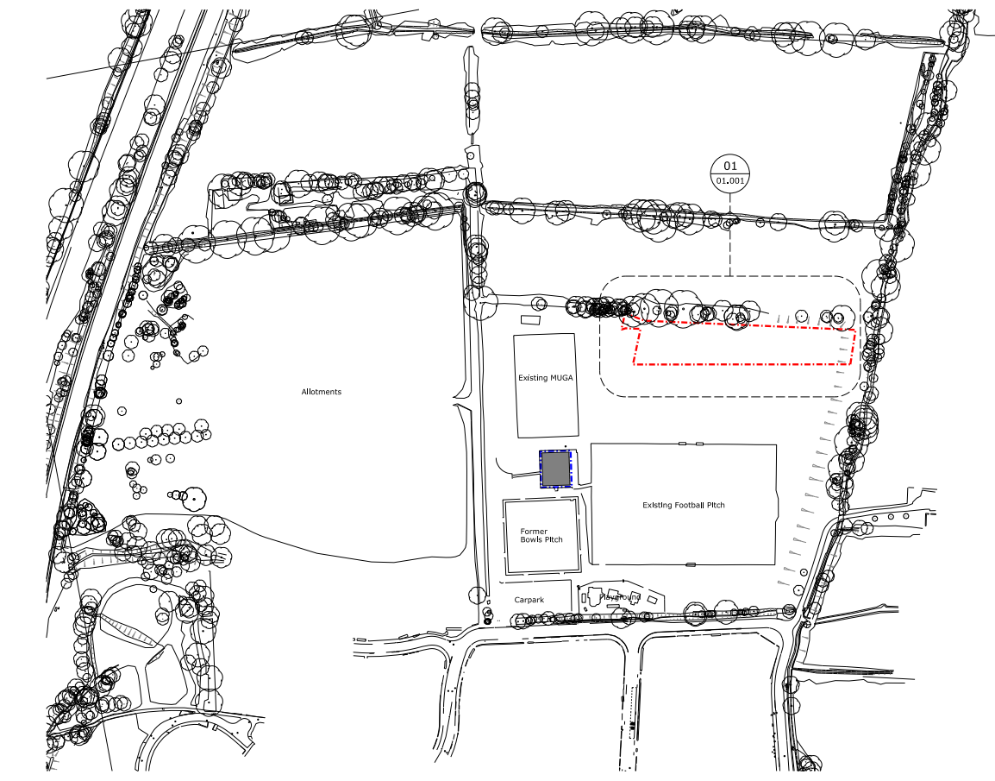

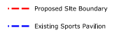

Appendix 2
Public Engagement

Consultation and Engagement – Statement of Community Involvement

This Statement of Community Involvement (SCI) together with the Design and Access Statement sets out the community engagement and stakeholder consultation undertaken to inform the proposals forming this submission.

Consultation has included:

- Pre-application engagement with OCC.
- Member Briefing of 3rd December 2015.
- 2 Meetings with BICEP during 2016.
- Pre application meetings with Phoenix Sports Association as set out below.

Phoenix Sports Association
The Phoenix Sports Association have been integral to the development of the replacement pavilion proposals. Aside from engagement over previous years more recently in the design development of the pavilion the following meetings have taken place

- 23rd March 2016 – First visit by David Morley Architects to the existing building. Existing facilities reviewed, critiqued and club requirements for new building established. Clubs requested a two-storey building.

- 12th May 2016 – Second meeting with clubs and DMA. Presented initial design proposals for both a single storey and two-storey option. Clubs agreed two-storey option not practical and to proceed with a single storey design.

- 17th May – First OCC pre-app

- 26th May – ODRP session

- 13th July – Second OCC pre-app

- 5th July – BICEP meeting. Presented current pavilion proposal, which was well received. Mick Beasley from Phoenix Association was in attendance.

- 7th July 2016 – Third design meeting with Phoenix Association. Presented final building layout, external finishes and M& proposals.

The Design and Access Statement provides further details on the design objectives established with the Phoenix Sports Association and Barton United together with the design amendments made to respond to the brief for the Pavilion.

At the meeting on the 7th July there was unanimous agreement by Phoenix Association to proceed with planning application on current design. At this meeting the design of the Pavilion was also supported by Councillor Van Coulter as the local member and Chair of the East Area Planning Committee.

Appendix 3
Oxford Design Review Panel Response

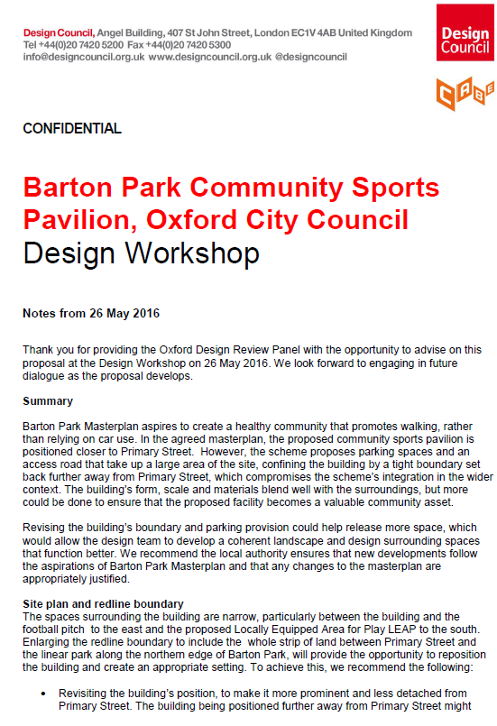

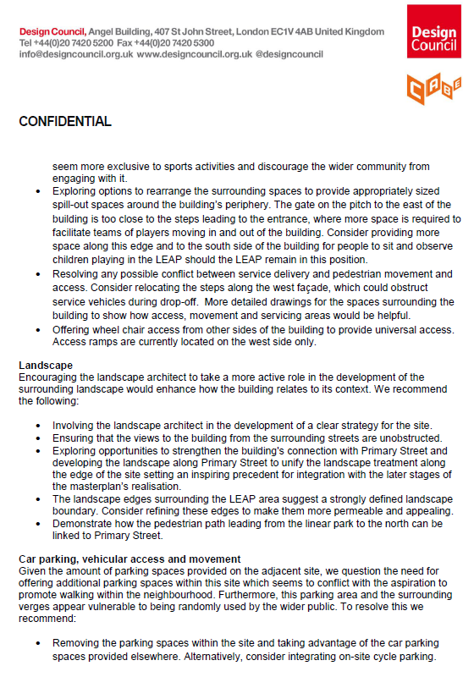

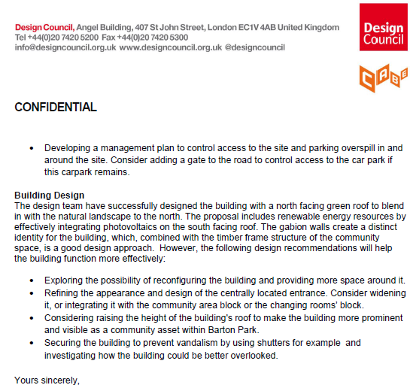

Appendix 4
Applicants Response to ODRP Comments

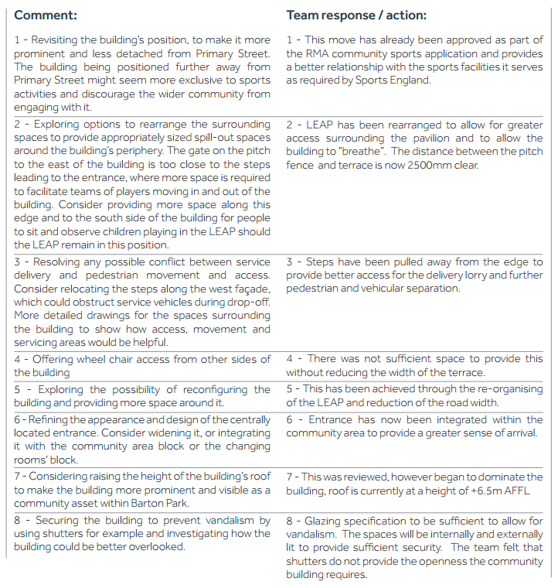

Appendix 5
Illustrative Master Plan

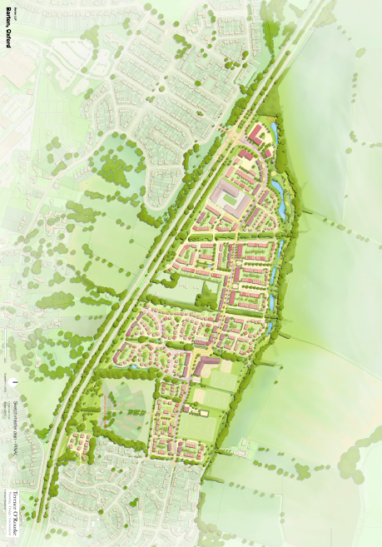

Appendix 6
Parameter Plan 6
Building Heights

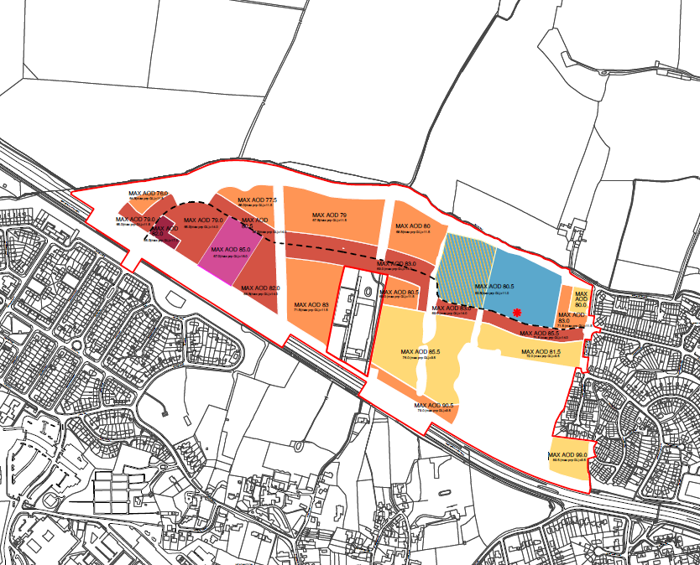
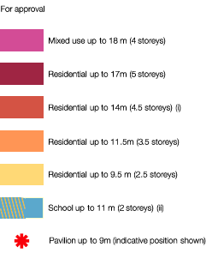
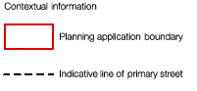
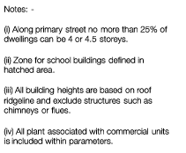

Appendix 7
Summary of Compliance with the Design Code

